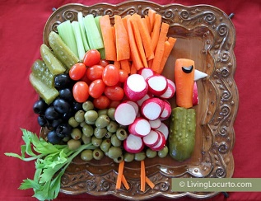

Turkey Vegetable Tray

Servings = 6 serving size: ½ cup serving = 3 grams carb

Ingredients:
Item(s) | Amount | x2 recipe
Pickles | 1 whole + ½ cup sliced vertically | 2 whole + 1 cup sliced vertically
Carrots | 1 whole + ½ cup sliced vertically | 2 whole + 1 cup sliced vertically
Radishes | ½ cup sliced round | 1 cup sliced round
Celery stick | ½ cup sliced vertically, 1 sprig | 1 cup sliced vertically, 2 sprigs
Grape tomatoes | ¼ cup | ½ cup
Black olives | ¼ cup | ½ cup
Green olives | ¼ cup | ½ cup

Procedure:
- Slice a carrot and pickle in half. Then cut one side to make a flat surface.
- Place the pickle on the bottom right corner of a large platter.
- Place the carrot on top of the pickle.
- Begin adding radishes, olives and tomatoes in bunches to form the Turkey’s body.
- Add sliced pickles, celery and carrots for wings.
- Cut turkey feet from carrots and place onto plate.
- Add the celery sprig for more feathers.
- Cut an eye out of a black olive and place onto carrot.
- Cut a triangle out of a radish for the beak.
- Slice another radish for the Turkey’s snood. (The red thing on the turkey’s chin)
- Cover and refrigerate your Turkey veggie tray or serve right away.

Equipment Needed: Large Platter, cutting knife
Fun Fact: You can tell a turkey’s emotions by the color of their heads. They change from red to blue to white, depending on how excited or calm they are. The more intense the colors are, the more intense their emotions.

